**Creating and Using the EXOS Virtual Switch in Oracle Virtual Box**

|  |  |  |
| --- | --- | --- |
| **Name** | **Version** | **Comments** |
| MHELM | 0.2 | Refreshing a rather old application note |
|  |  |  |
|  |  |  |
|  |  |  |
|  |  |  |

Table of Contents

1. Introduction & Purpose 3

2. Downloading and Preparing OVB 3

3. Creating an "Host-Only" Network in OVB 4

4. Creating and using an EXOS VM 5

5. Networking with the EXOS VM in OVB 9

6. Caveats 11

## Introduction & Purpose

This guide provides instructions for creating and using the EXOS VM (virtual switch) within Oracle Virtual Box. Oracle Virtual Box. From the OVB online manual:

"VirtualBox is a cross-platform virtualization application. What does that mean? For one thing, it installs on your existing Intel or AMD-based computers, whether they are running Windows, Mac, Linux or Solaris operating systems. Secondly, it extends the capabilities of your existing computer so that it can run multiple operating systems (inside multiple virtual machines) at the same time. So, for example, you can run Windows and Linux on your Mac, run Windows Server 2008 on your Linux server, run Linux on your Windows PC, and so on, all alongside your existing applications. You can install and run as many virtual machines as you like -- the only practical limits are disk space and memory."

The EXOS virtual switch can be used to build a network within OVB by which VMs can be interconnected. Complete network topologies can be created. This is extremely valuable in that network configurations and protocols can be tested thoroughly without the need for any physical equipment.

## Downloading and Preparing OVB

Find and download Oracle Virtual Box from here: <https://www.virtualbox.org/wiki/Downloads>

Oracle Virtual Box best functions with the addition of the Extension Pack. To install the OVB Extension Pack, download it (per the link above) and then install it as follows:

1. Start up OVB
2. Enter the Preferences dialog
3. Enter the Extensions dialog
4. Click on the Add Package button
5. Select the Extension pack file (e.g. Oracle_VM_VirtualBox_Extension_Pack-5.0.20-106931.vbox-extpack)
6. Accept the Terms and Conditions
7. Click OK.

## Creating an "Host-Only" Network in OVB

Prepare OVB for the “out-of-band” management of EXOS VMs as follows:

1. Enter the Preferences dialog

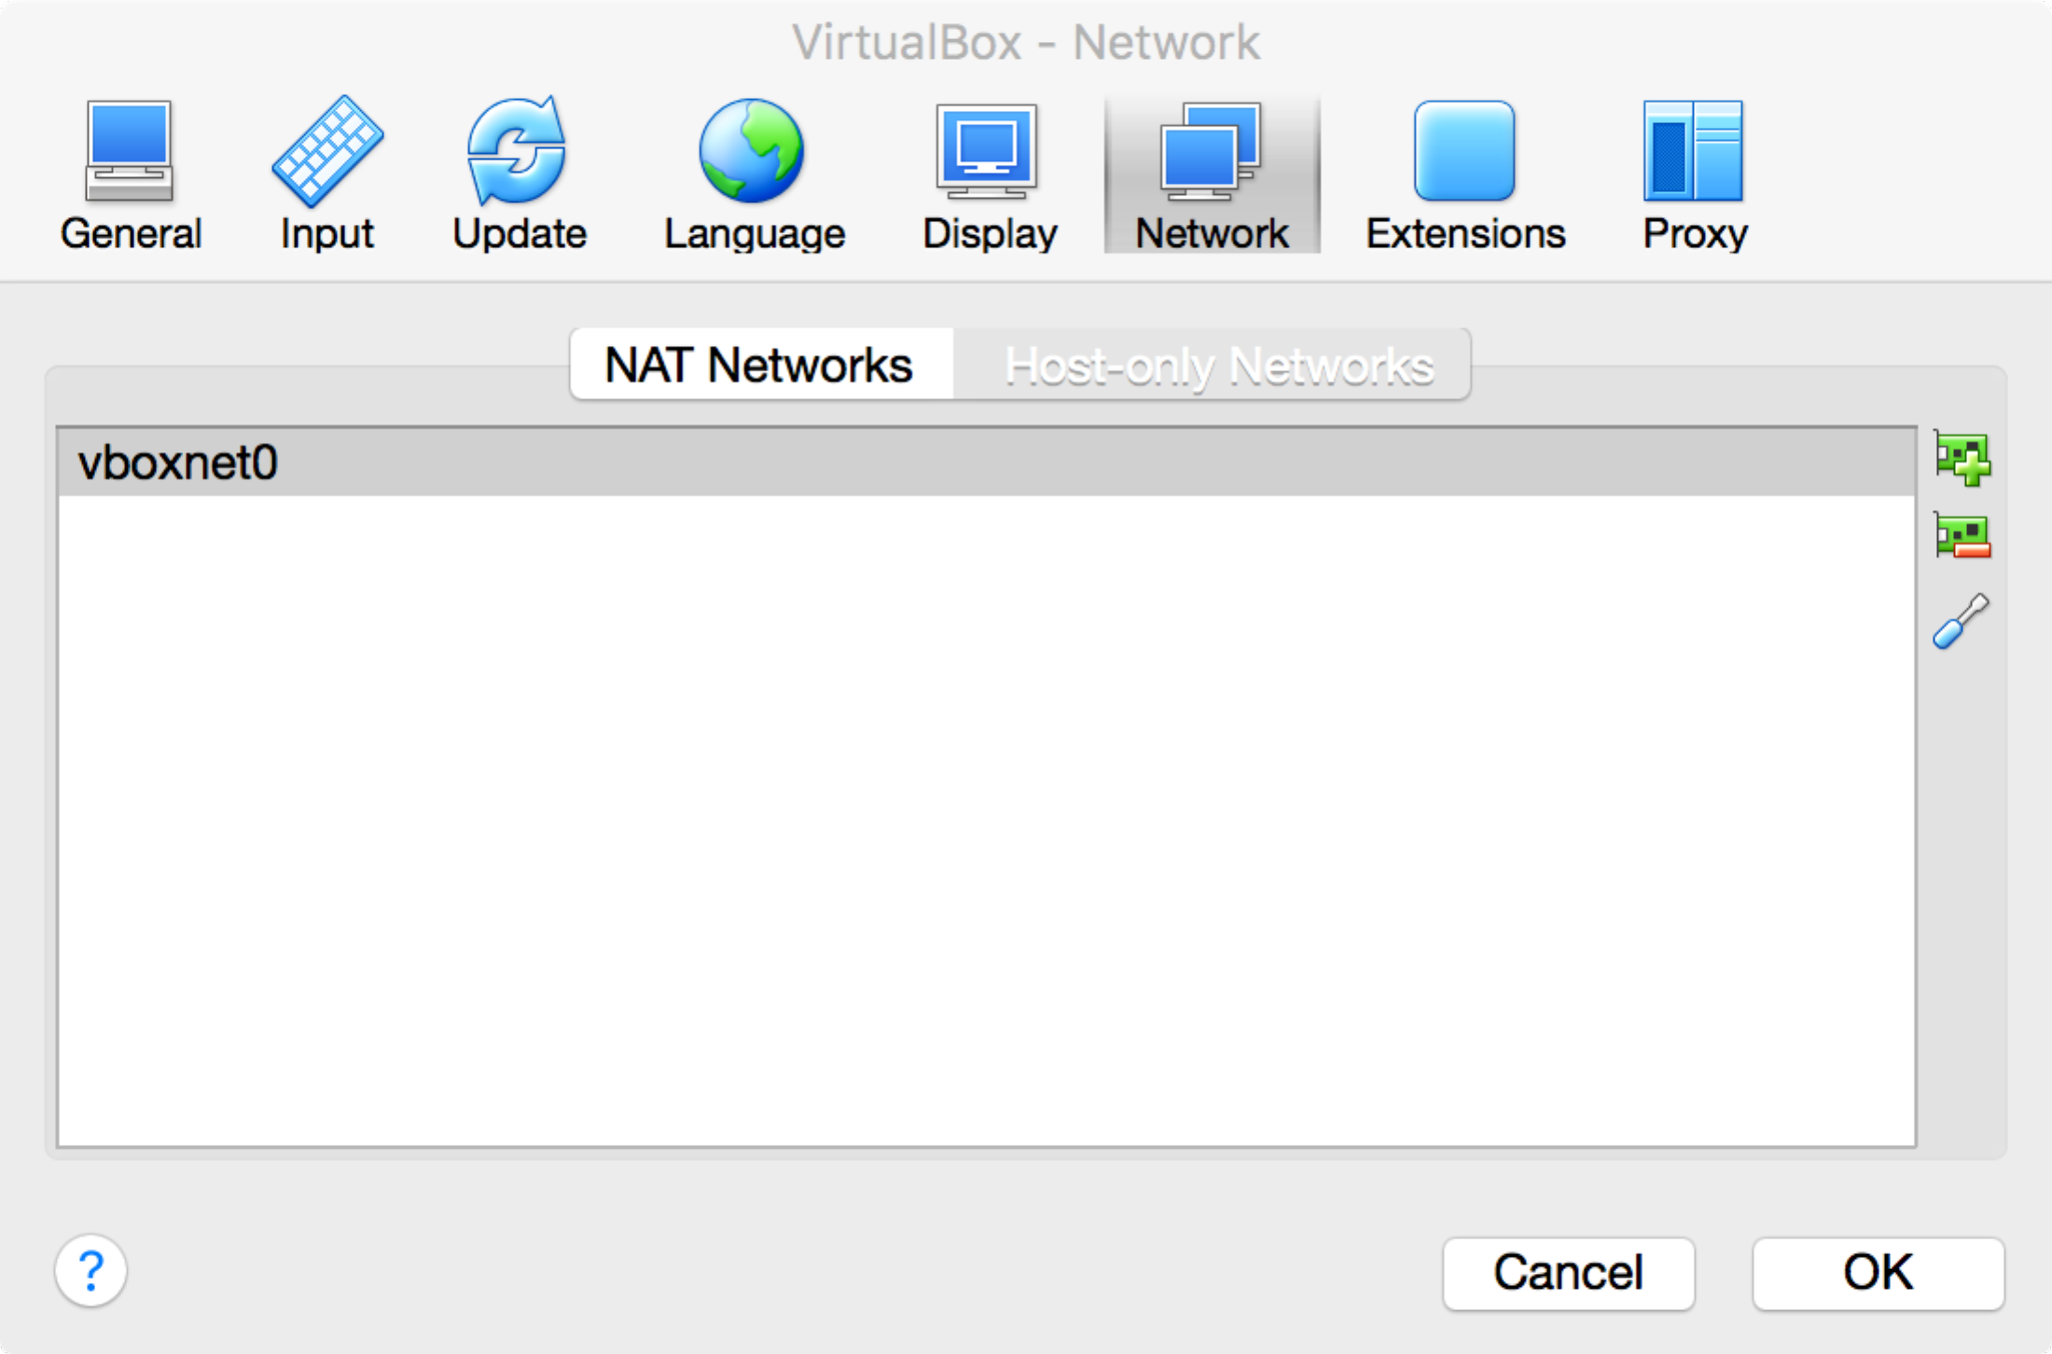

1. Enter the Network dialog
2. Select the Host-only Networks tab
3. Click on the Add Host-Only Network button
4. Select the new Host-Only Network Adapter
5. Click on the Edit Host-Only Network button

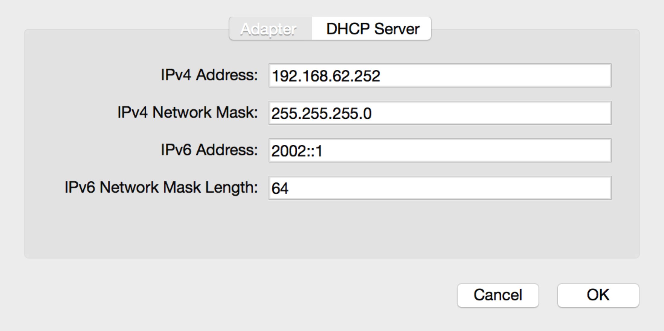

1. 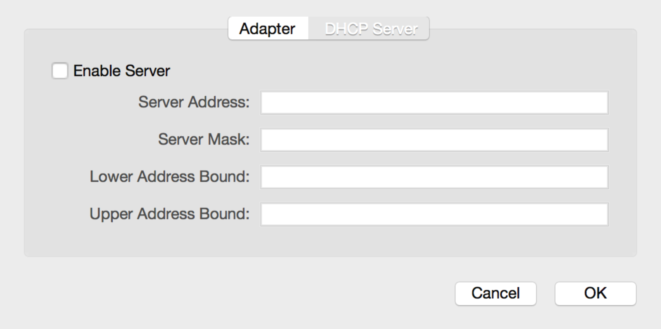In the Adapter dialog, determine an unique subnet (one not used by any other adapter on your host) and give the Host-Only Network Adapter an appropriate unique IP address and mask in that subnet.
2. Enter the DHCP Server tab/dialog and uncheck the box for the server disabling it.

## Creating and using an EXOS VM

Get the latest EXOS .iso file from your Extreme SE (E.g. vm-21.1.1.4-patch1-2.iso).

Create an EXOS VM with the following steps:

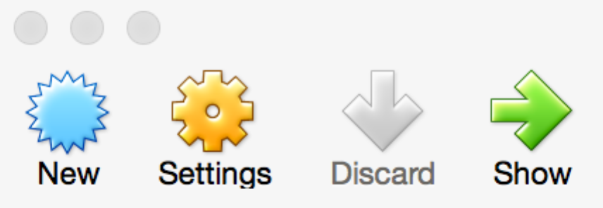

1. Click the "New" ICON.

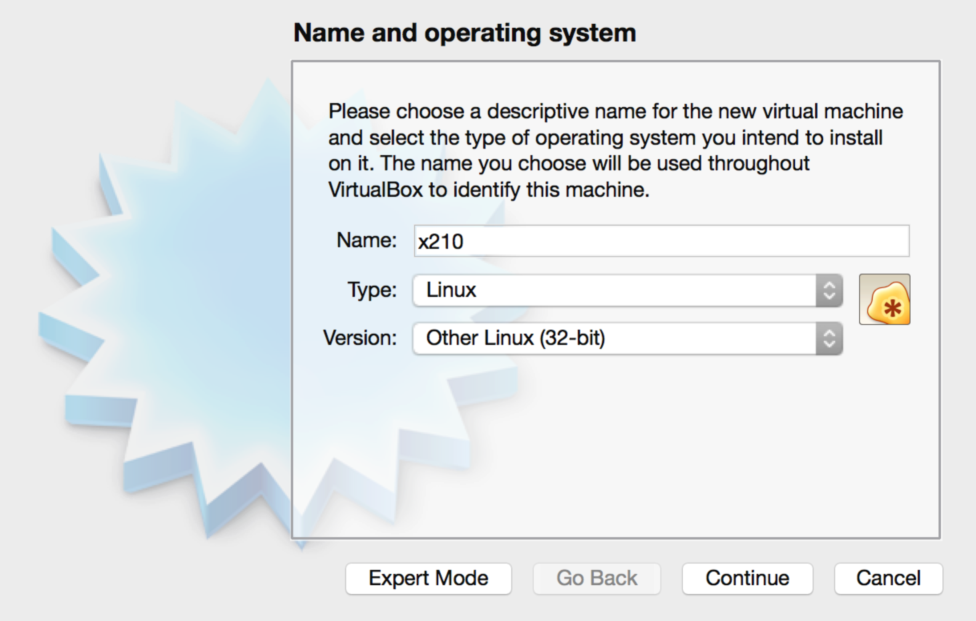

1. Choose "Linux" for Type.
2. Choose "Other Linux (32-bit)" for Version.
3. Type a name in the Name field (e.g. "x210") and click Continue.

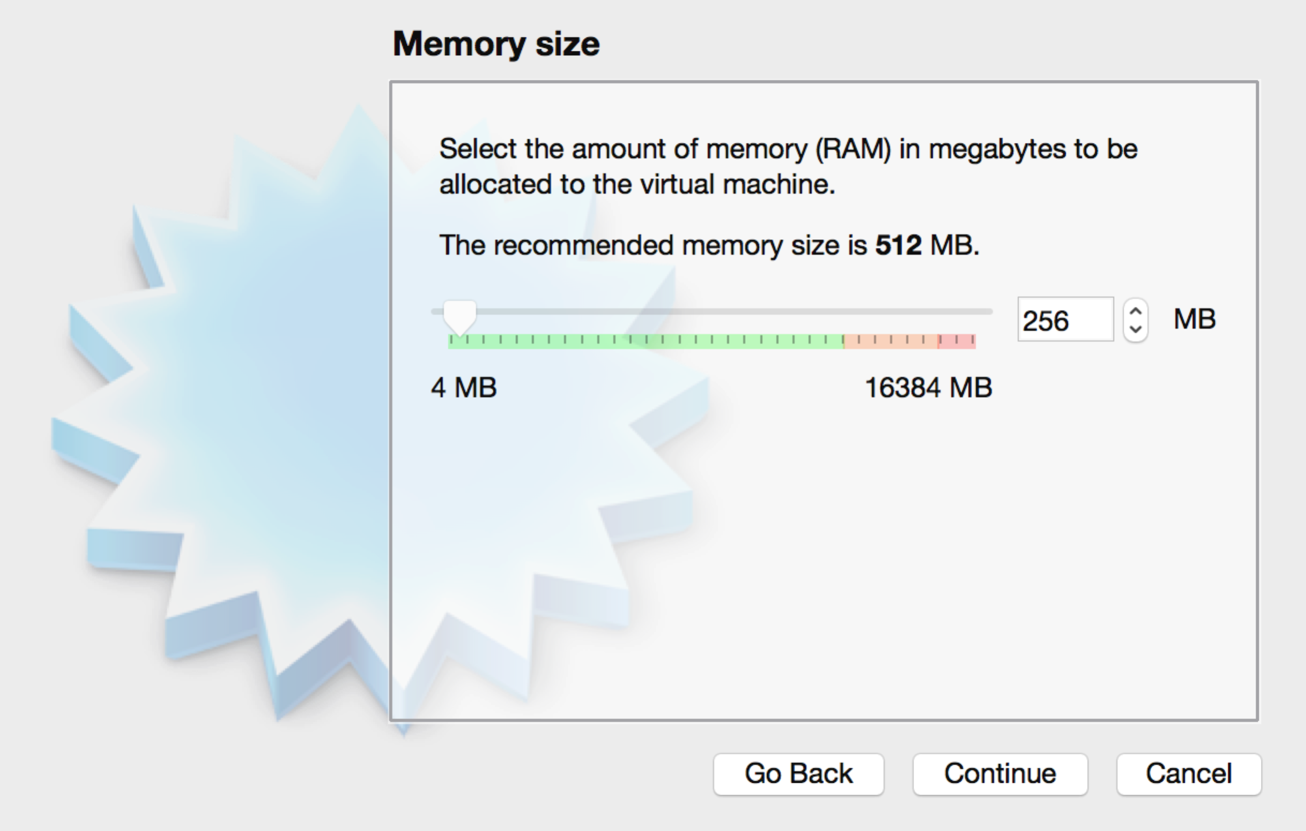

1. Set the memory size to be 256MB and click Continue.

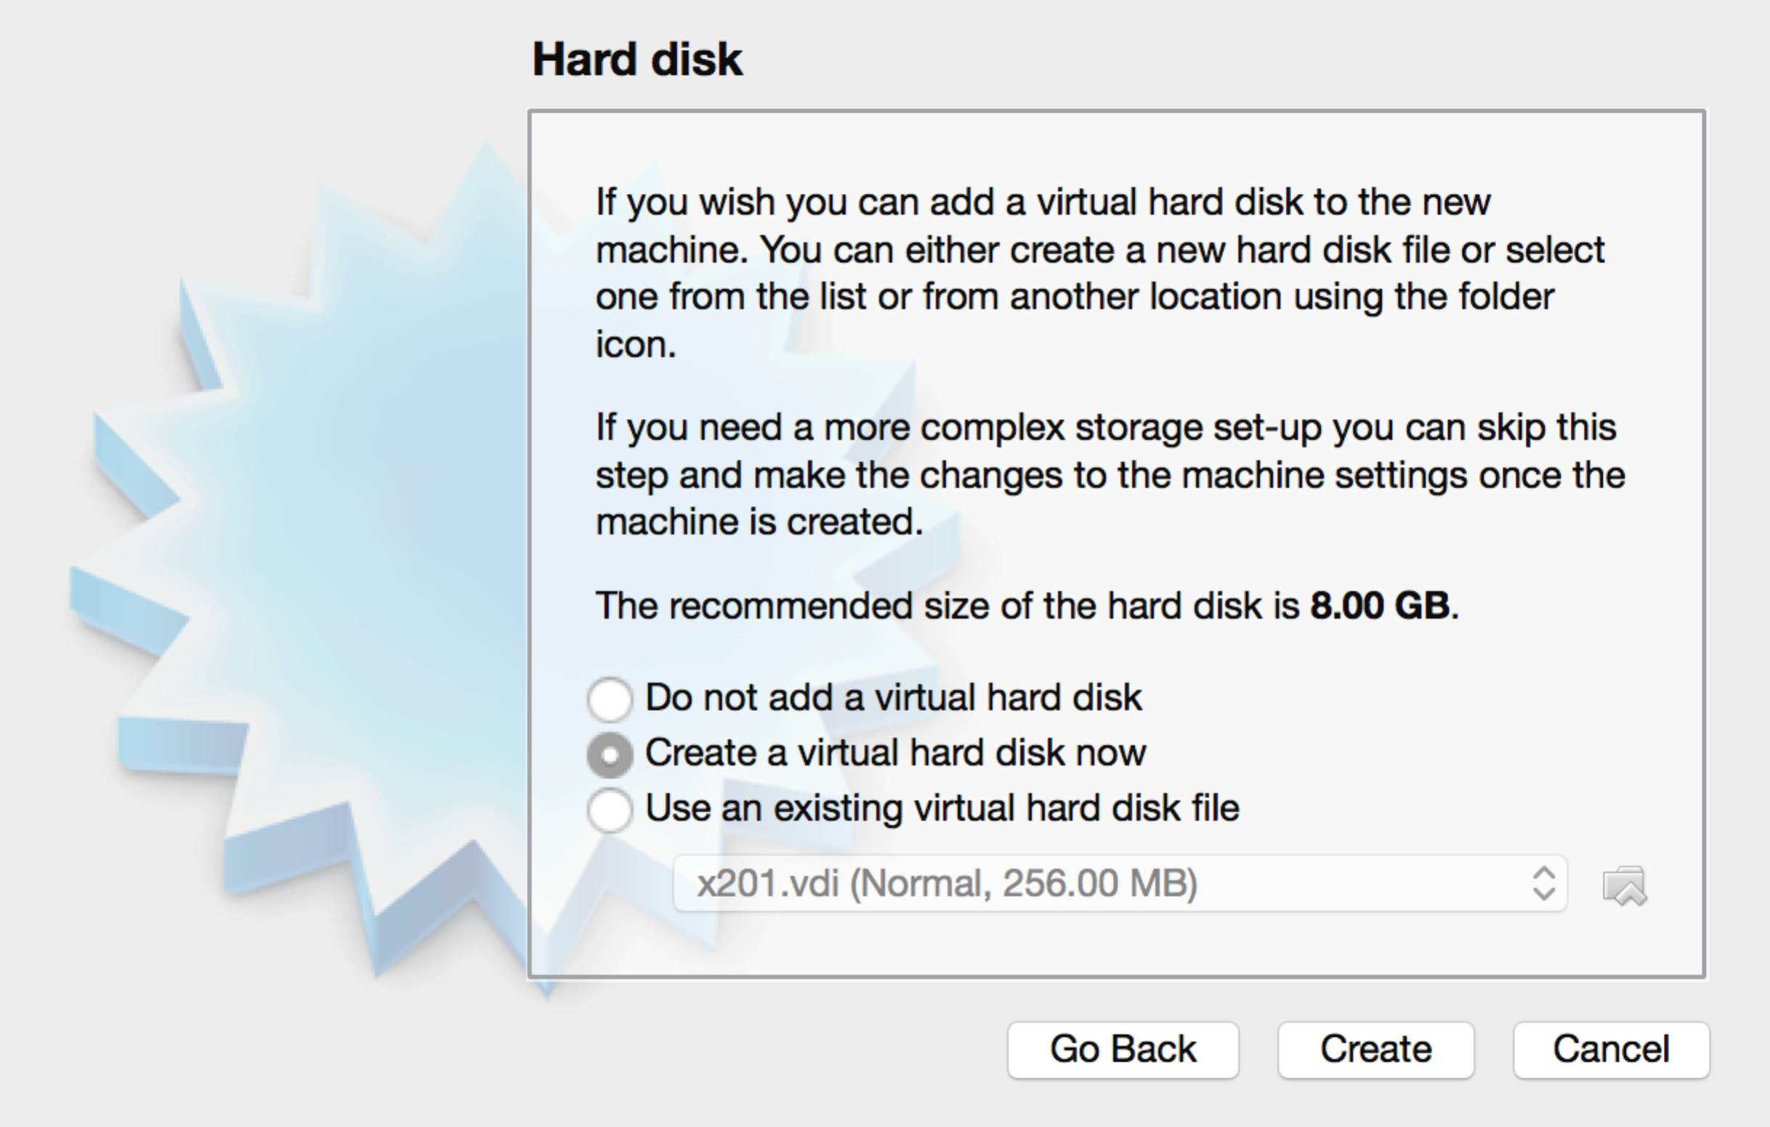

1. Select "Create a virtual hard drive now" and click Create.
2. 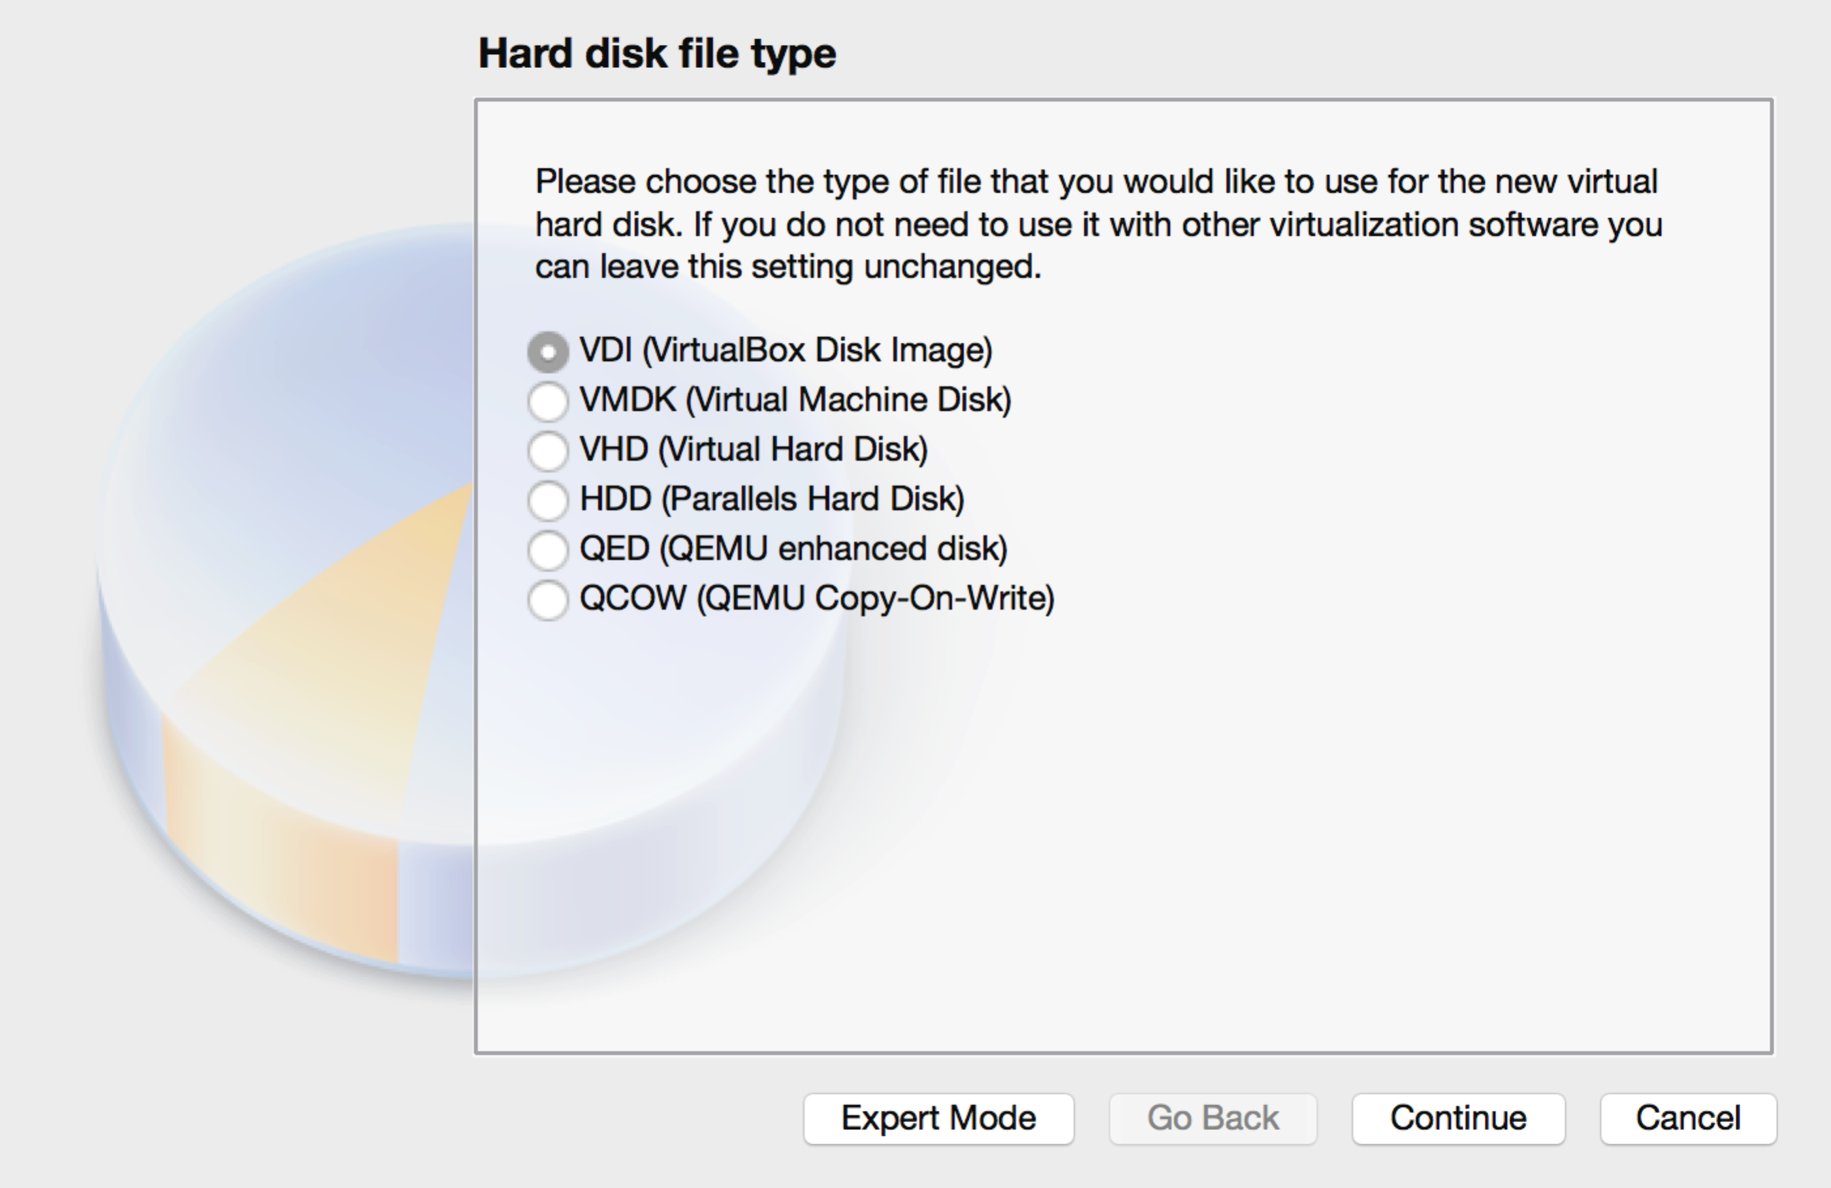Select VDI and click Continue.

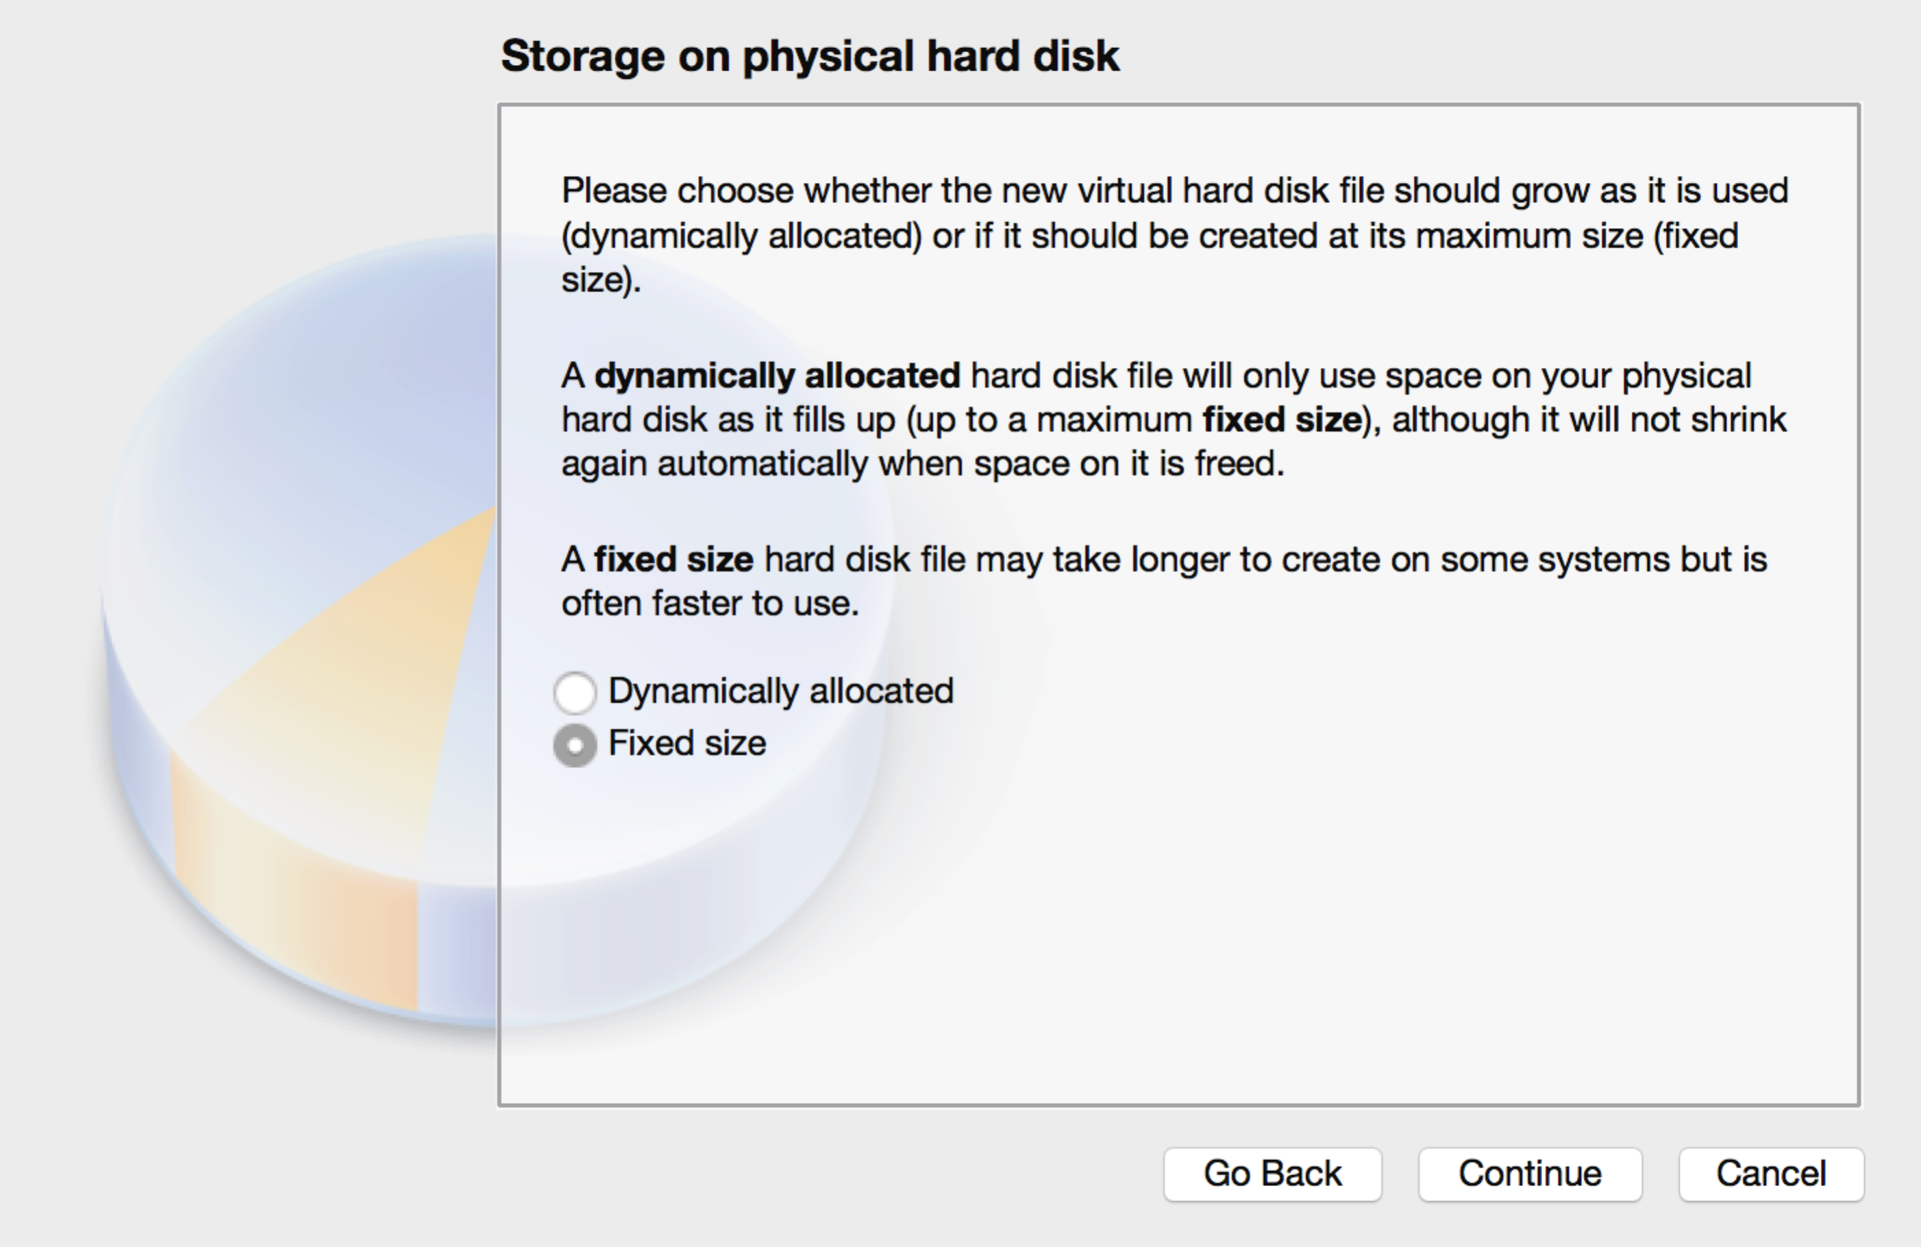

1. Select "Fixed size" and click Continue.

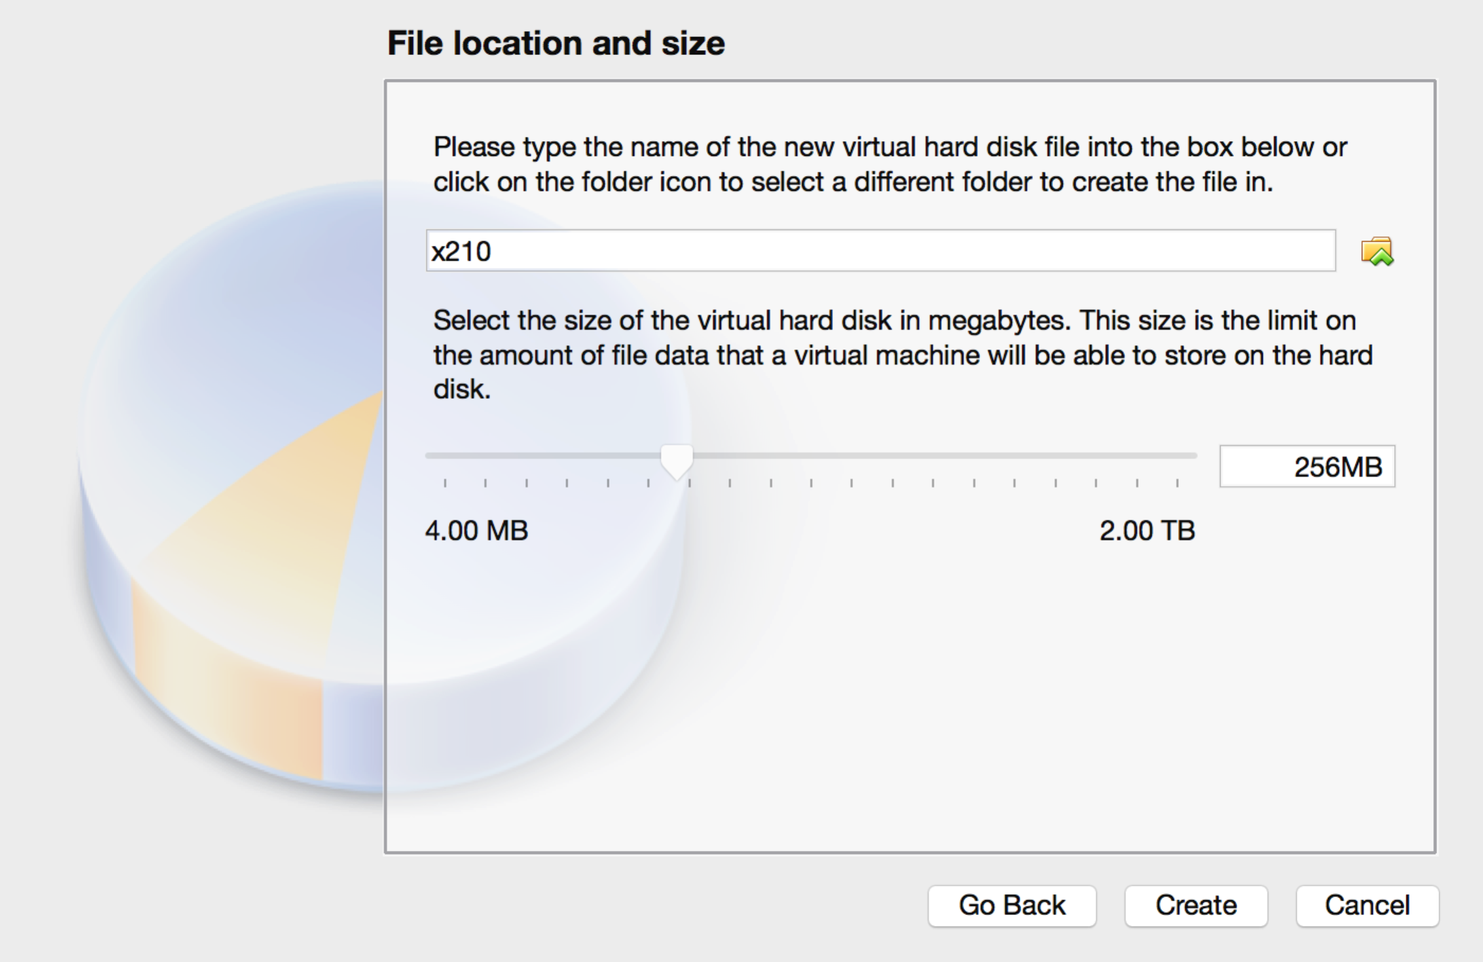

1. Type in 256MB in the size field and click Create.
2. Double click on the newly created but powered off virtual machine that should appear in the left frame in the Oracle VM Virtual Box Manager window.
3. Select the EXOS VM .iso file and click Start.

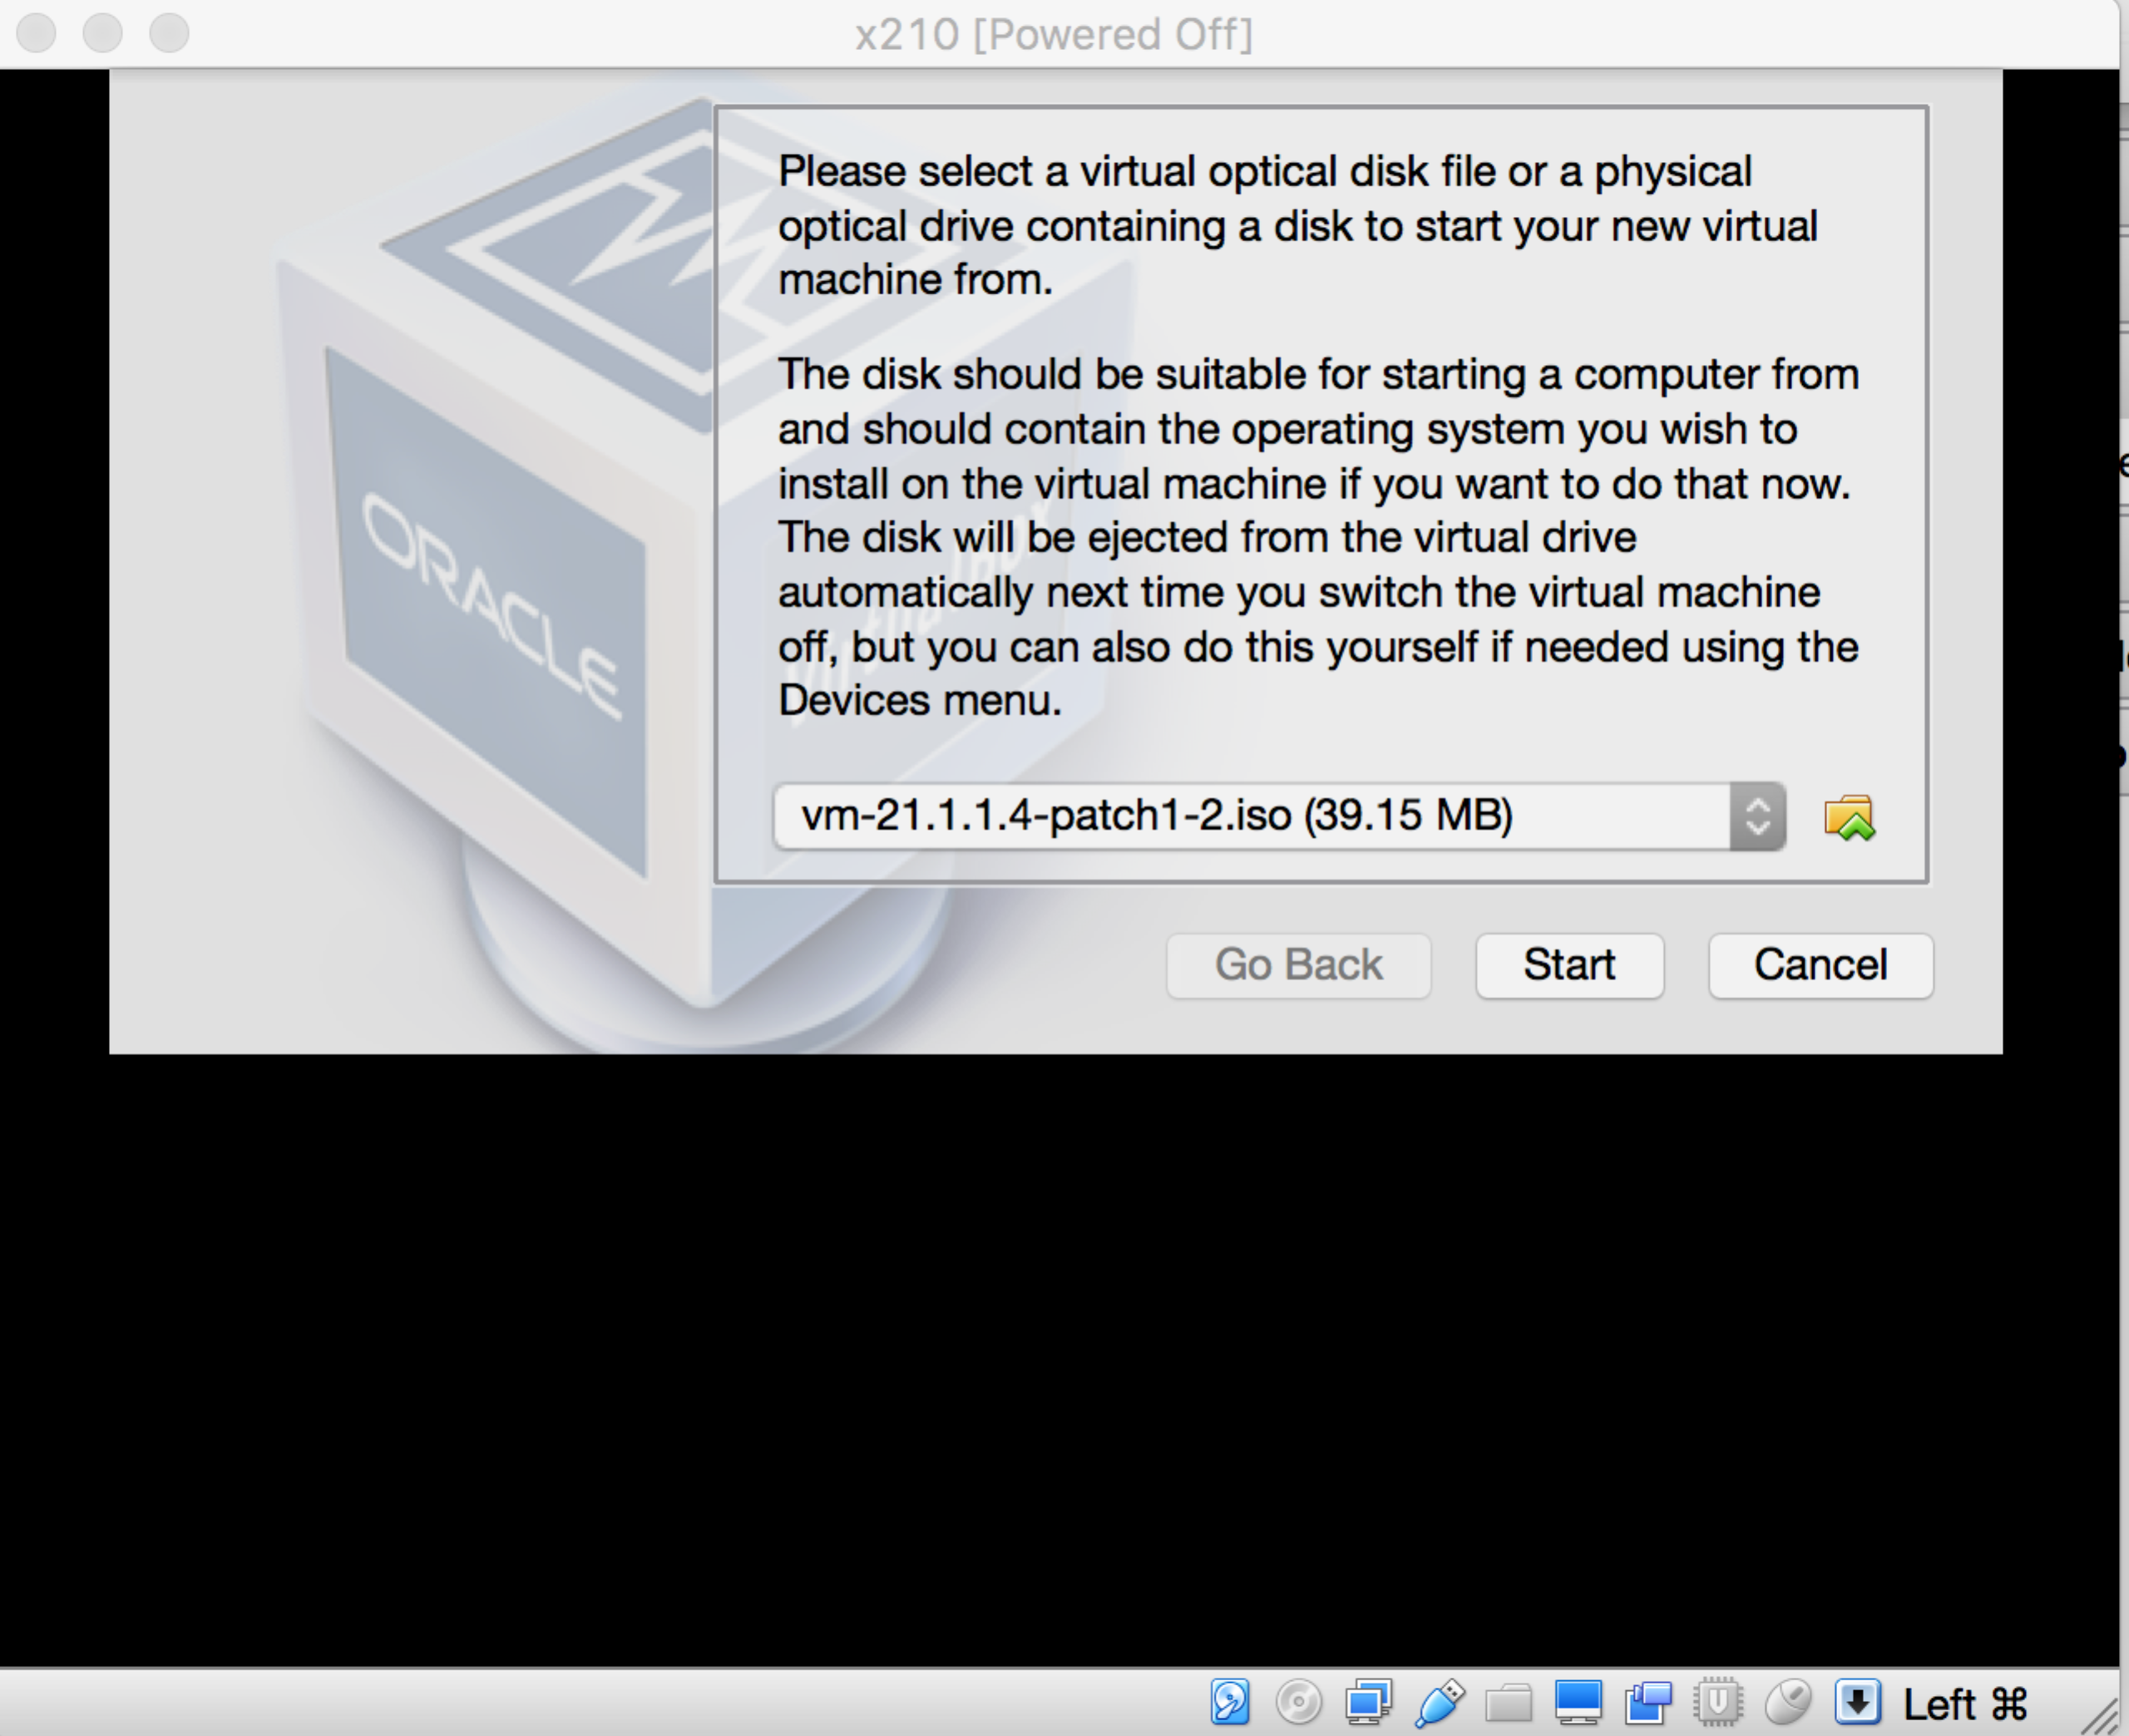

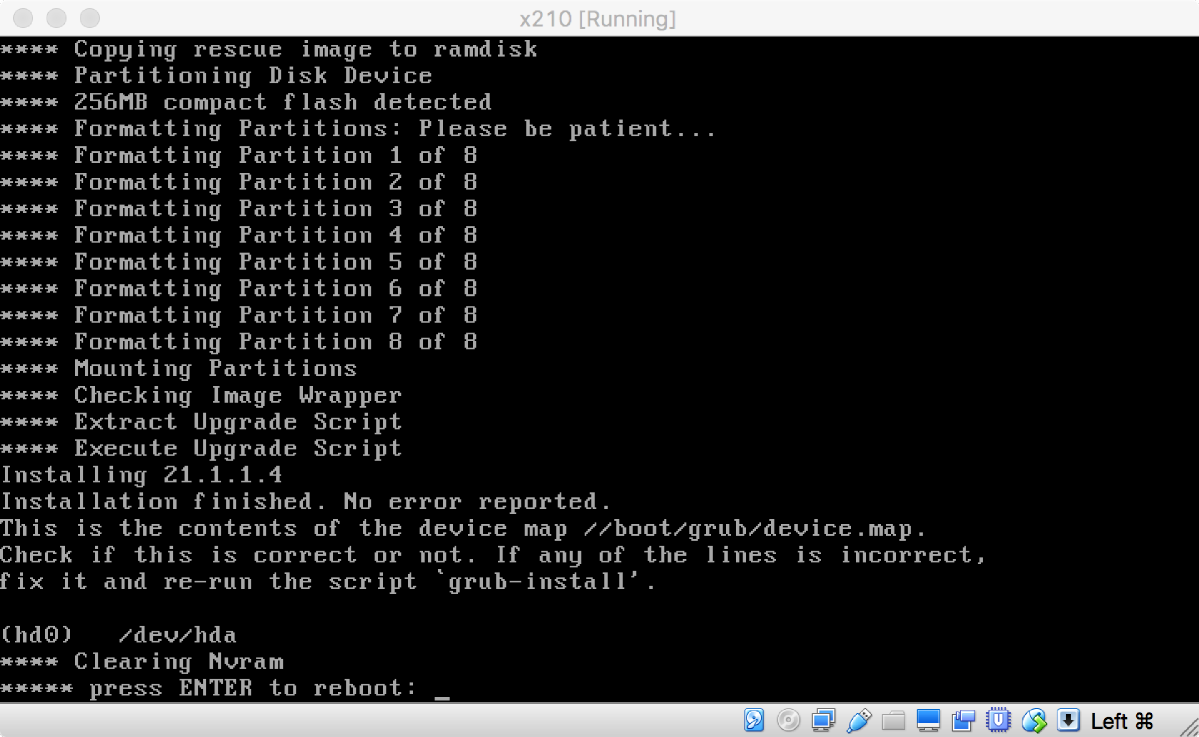

1. At this point, the EXOS virtual machine window should launch and there will be a prompt to erase and format the "External Memory Card". Type "y" and hit Return.

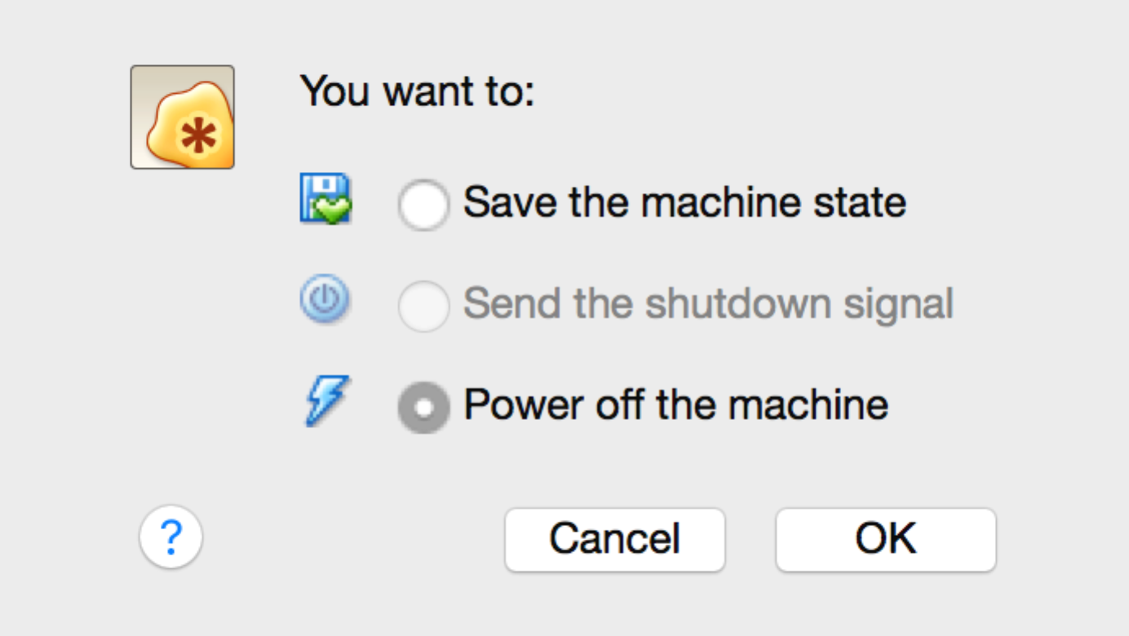

1. When the formatting process finishes and the prompt reads "press ENTER to reboot", do **not** hit enter, but instead close the window and choose the option to "Power off the machine" and click OK.

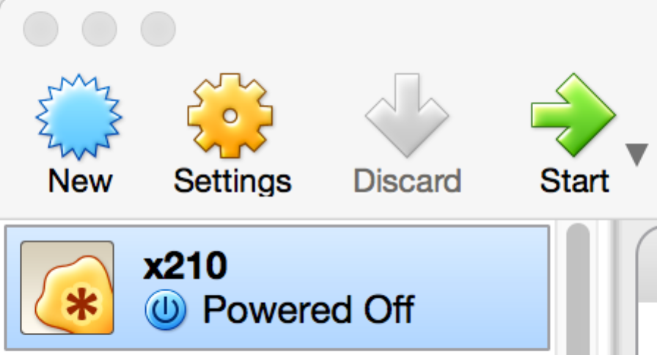

1. Select the new VM in the left frame in the Oracle VM Virtual Box Manager window and click Settings.

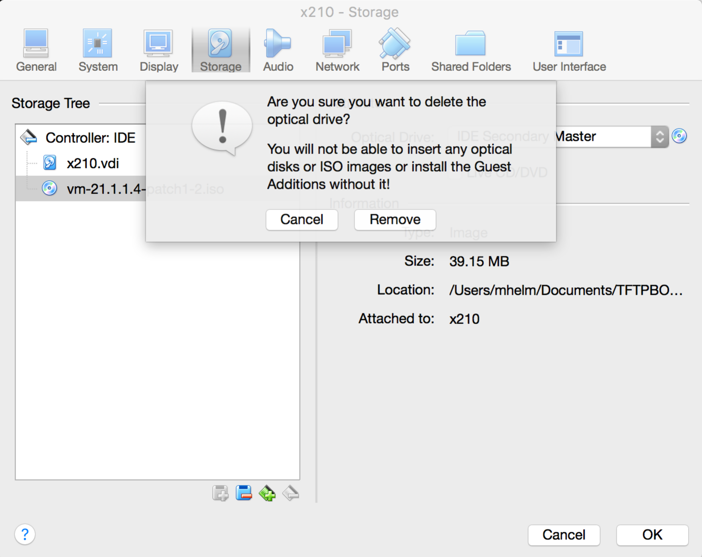

1. Click on the Storage tab within the VM's settings window select the .iso "optical drive" in the storage tree dialog on the left and click the Remove media icon at the bottom and then click the Remove button.
2. 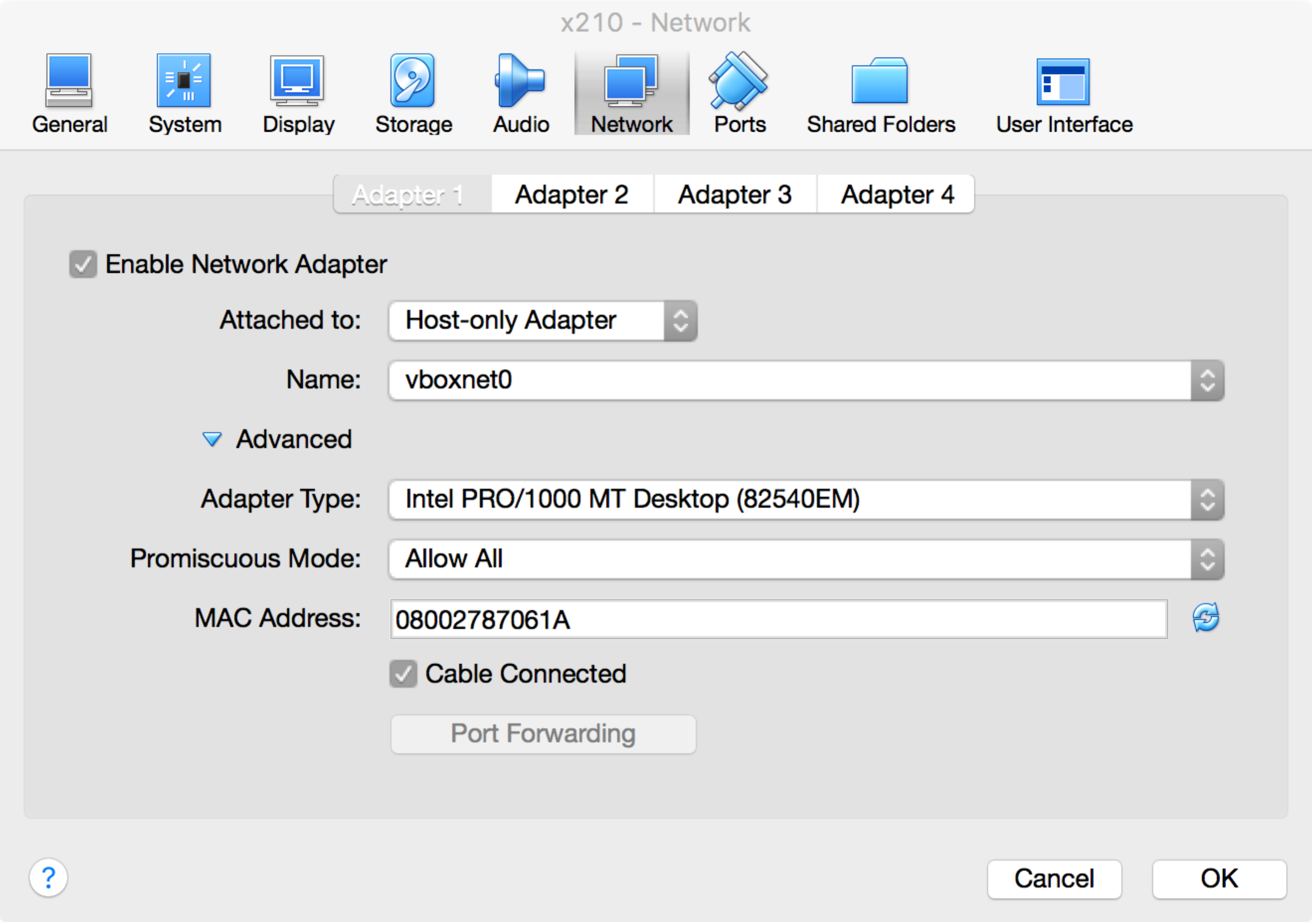Optionally, click the Audio tab and deselect the "Enable Audio" check box.
3. Click the Network tab and then on the "Adapter 1" sub-tab widow, using the "Attached to:" drop-down list select the "Host-only Adapter" option. Click on Advanced and change the Promiscuous Mode to "Allow All".

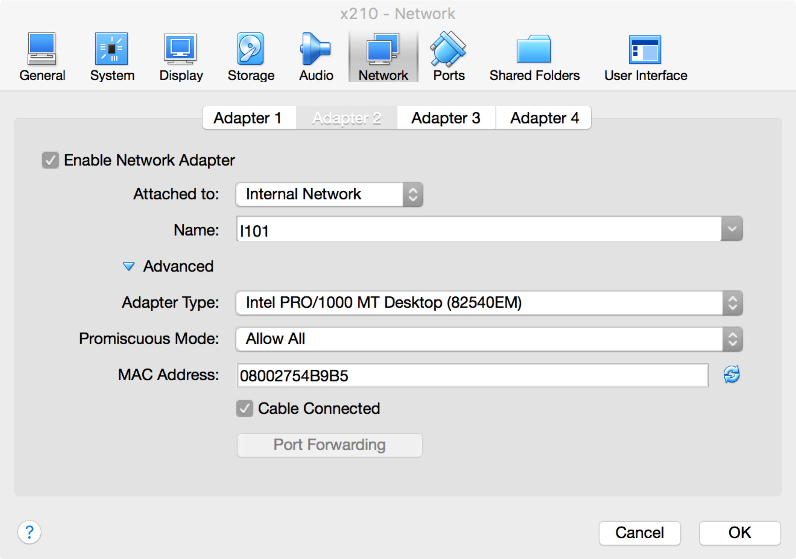

1. Enable and change the next three adapters to "Internal Network" giving each a unique name (e.g. I101, I102, and I103 respectively), and change the Promiscuous Mode on all three to "Allow All".
2. Lastly, click OK.
3. The EXOS VM is now ready. To start it, double click on it again within the left frame in the Oracle VM Virtual Box Manager window.

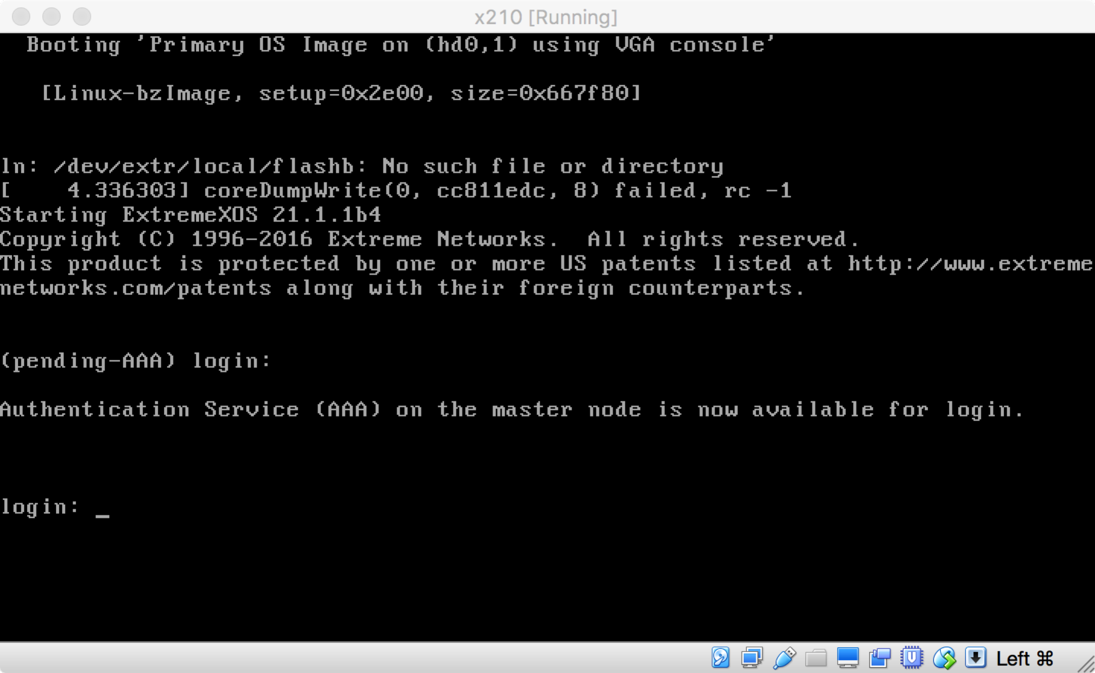

The EXOS VM is the same as any EXOS switch. The default administrator's login is "admin" with no password. The first adapter, in the Host-Only network, is the "out-of-band" management port associated with the MGMT VLAN and VR-MGMT.

The VM can be upgraded to a later EXOS image (e.g. vm-21.1.1.4-patch1-2.xos) through any VLAN with an IP, but in this case, it would probably be best to use the MGMT VLAN, which, once assigned the proper IP, should be able to communicate with the Host-Only interface on the host.

As of EXOS 21.1 there is no separate SSH XMOD, but for EXOS VMs with version 16.x and below there is an SSH XMOD available.

Lastly, like any EXOS switch, one can license the EXOS VM for any software capability using the trial license via the "debug epm enable trial-license" command.

## Networking with the EXOS VM in OVB

The EXOS VM can have up to 8 network adapters or "ports", the first of which, as mentioned above, is the MGMT port. The first four are accessible for configuration through the Settings GUI within the OVB manager. The remaining adapters/ports must be configured through "vboxmanage" shell commands.

Here is an example of a configuration for the 5th adapter (port 4 from the CLI of the virtual EXOS switch):

vboxmanage modifyvm x201 --nic5 intnet

vboxmanage modifyvm x201 --macaddress5 000496F201F5

vboxmanage modifyvm x201 --cableconnected5 on

vboxmanage modifyvm x201 --intnet5 l14

vboxmanage modifyvm x201 --nicpromisc5 allow-all

The main settings of an adapter that are of interest are the promiscuous mode (--nicpromisc) which should be set to allow-all, and the internal network name (-intnet).

An internal network is basically an isolated segment. Adapters on an internal network with the same name share that segment. To "connect" a port on one EXOS VM switch to a port on another EXOS VM switch, simply give the adapters the same internal network name. Below two switches share the same internal network name for their 2nd adapter. They are able to detect each other via EDP.

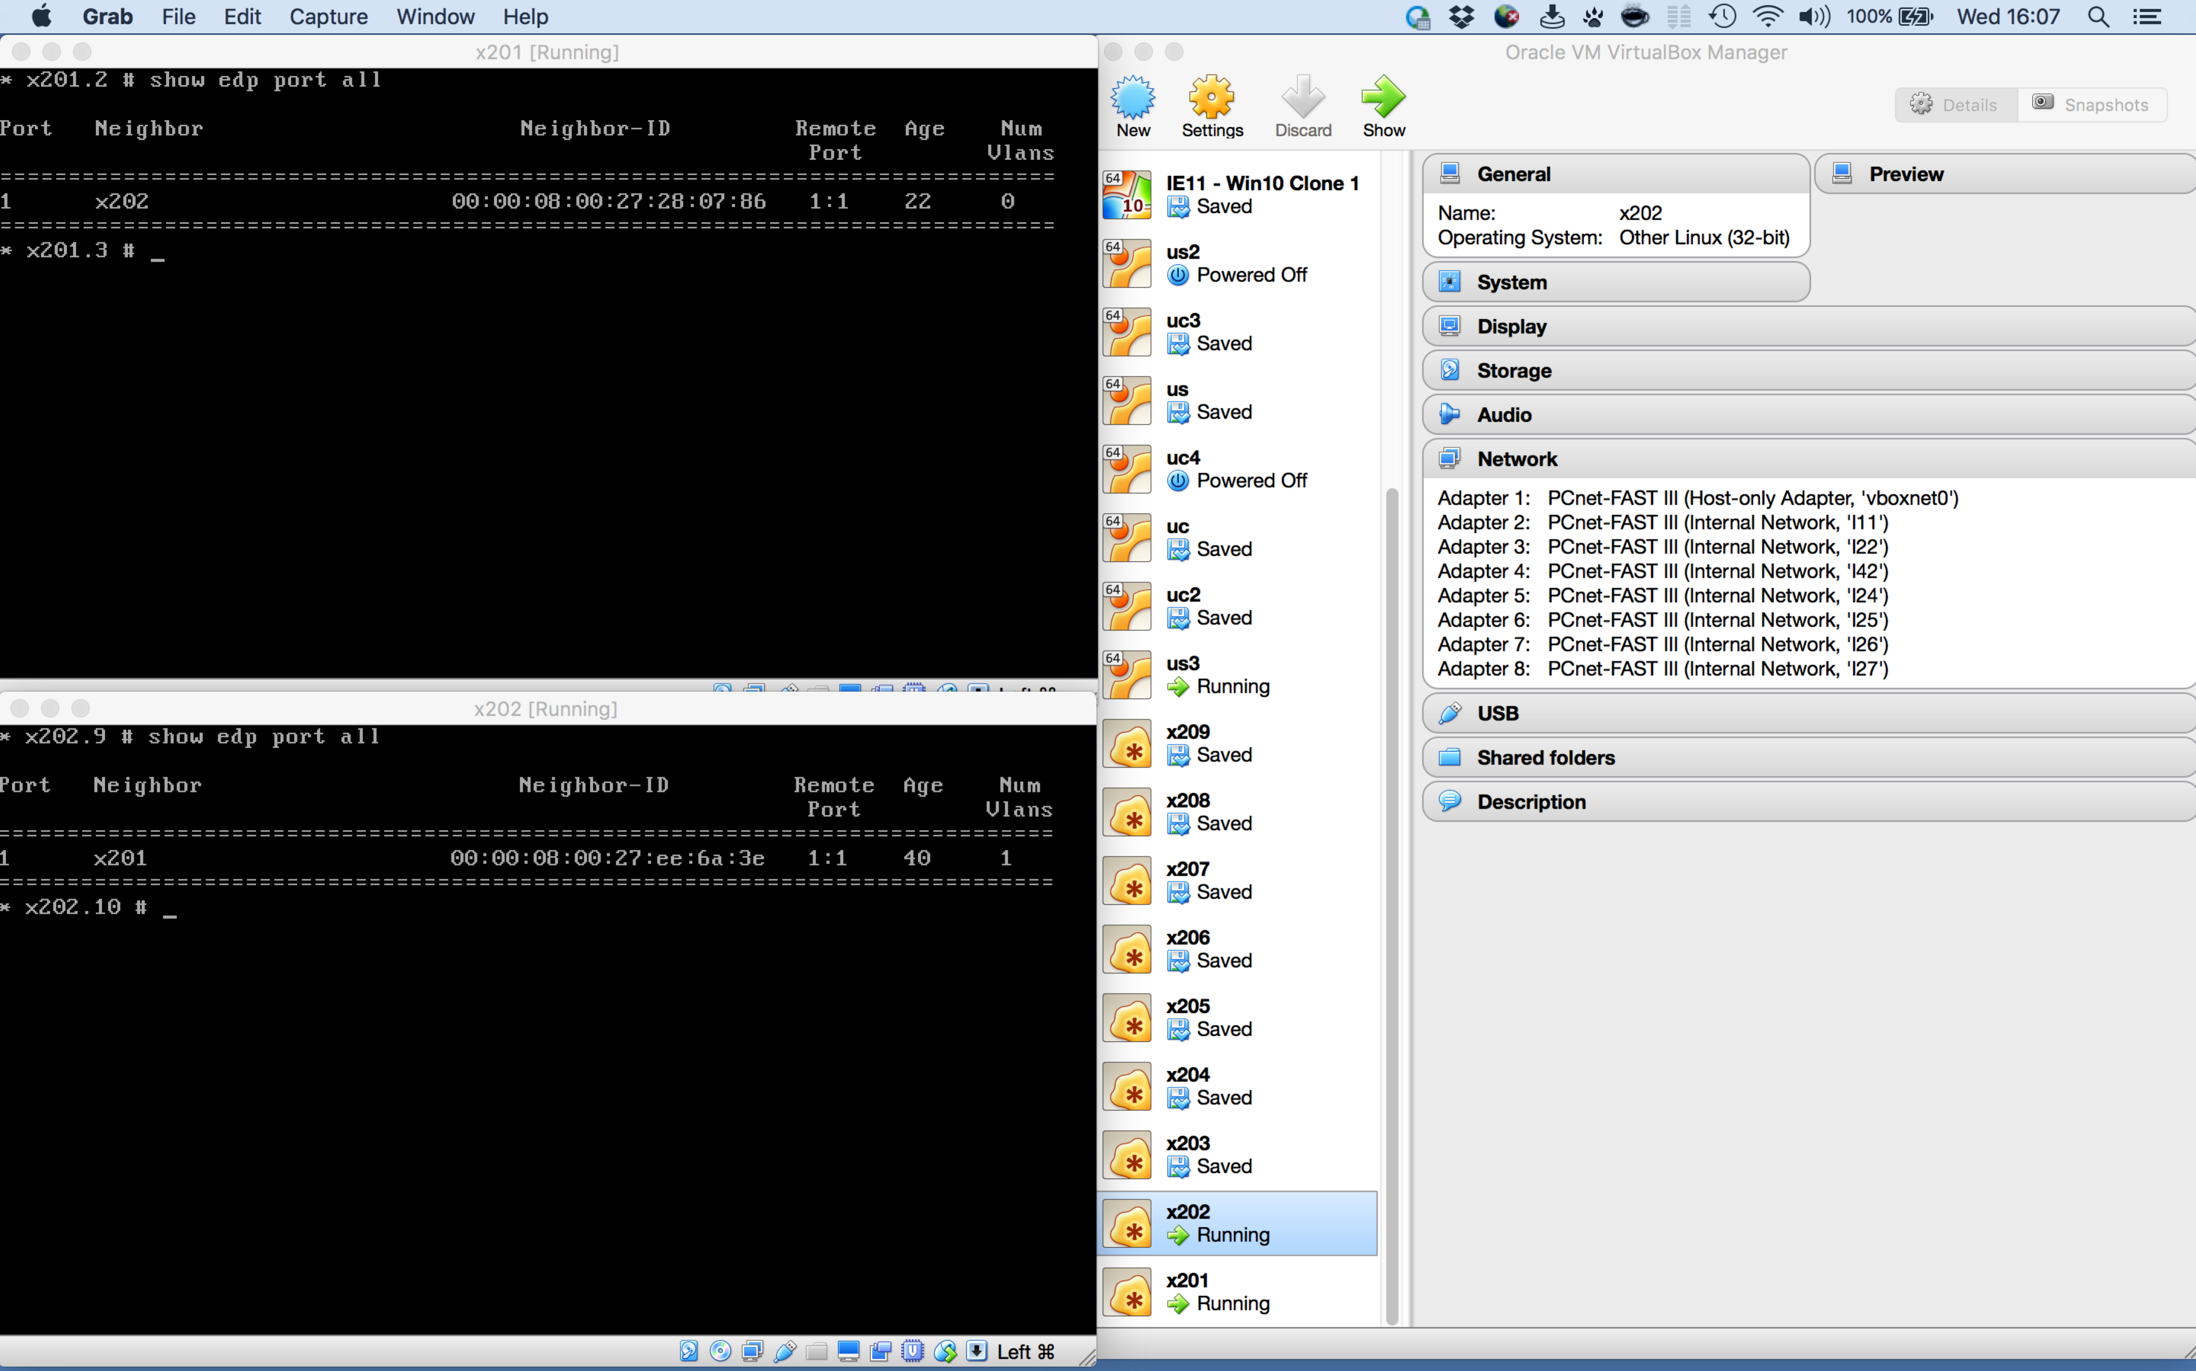

It should be noted, that if one disables a port from the CLI of an EXOS VM, the port on another VM sharing the same internal network with the disabled port will **not** show as "down". Instead, the internal adapters on both switches would need to be disabled to show both ports as "down" simultaneously.

Shell scripting provides a convenient way configure EXOS VM adapters and possibly to create virtual networks. The following PERL script creates and/or modifies the 7 non-MGMT ports on a series of EXOS VMs named “x201”, “x202”, etc. when its output is piped into a shell.

$ cat vnic.pl

#!/usr/bin/perl

my $i = 2;

my $j = 1;

my $p = 201;

my $n = $p - 200;

while ($p < 210) {

$i = 2;

while ($i < 9) {

$j = $i - 1;

print "vboxmanage modifyvm x$p --nic$i intnet\n";

print "vboxmanage modifyvm x$p --macaddress$i 000496F$p";

print "F$i\n";

print "vboxmanage modifyvm x$p --cableconnected$i on\n";

$n = $p - 200;

print "vboxmanage modifyvm x$p --intnet$i l$n";

print "$j\n";

print "vboxmanage modifyvm x$p --nicpromisc$i allow-all\n";

$i = $i + 1;

}

$p = $p + 1;

}

$ perl vnic.pl | sh

Similar scripting could be used for a group of EXOS VMs whereby their interconnections are created to form a specific network topology.

## Caveats

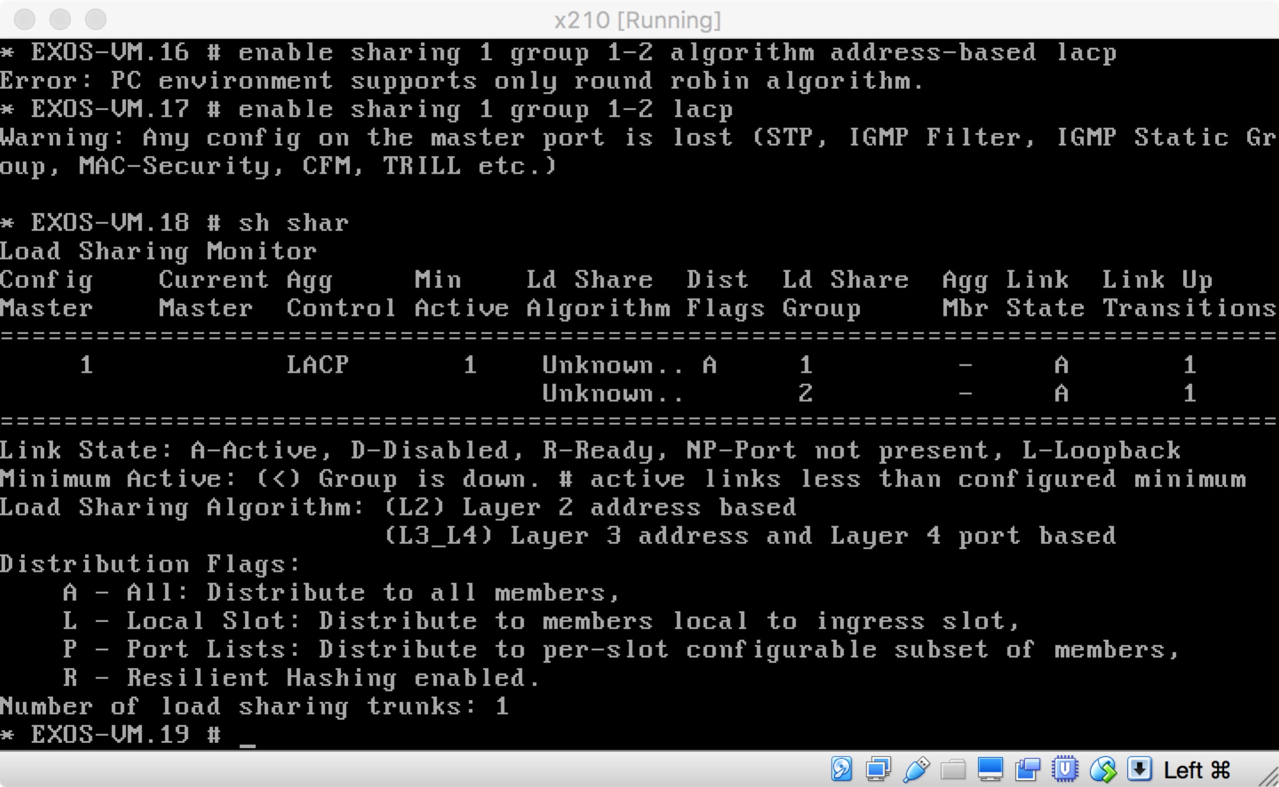Certain features do not work well on the EXOS VM due to their relation to the capabilities of the underlying hardware.

For instance, while port sharing (LAG) works using LACP, it only can use the round-robin load-sharing algorithm, that is, the address-based algorithms are not available and LACP is required.

Attempts to get OpenFlow working via the OpenFlow XMOD end badly (i.e. the EXOS VM crashes immediately with the first installment of a flow).

Lastly, while ACLs and ACL counters appear to work as expected, Clear-Flow does not work despite being configurable.